PARTH RAMESH HOLE  
ADT23SOCB0700

TY AIEC-1-36

ASSIGNMENT 1

Design a mini project that maps a data lifecycle (capture to visualization) for a real-world problem in the retail/healthcare domain

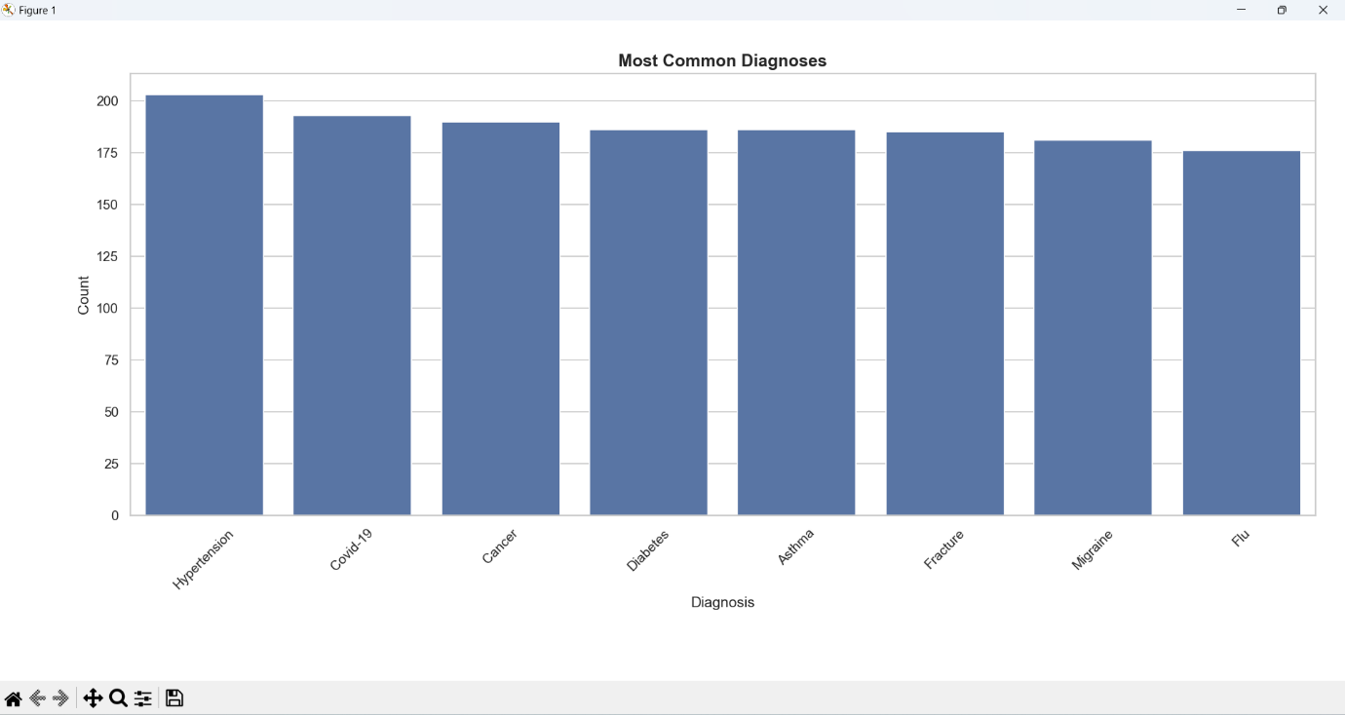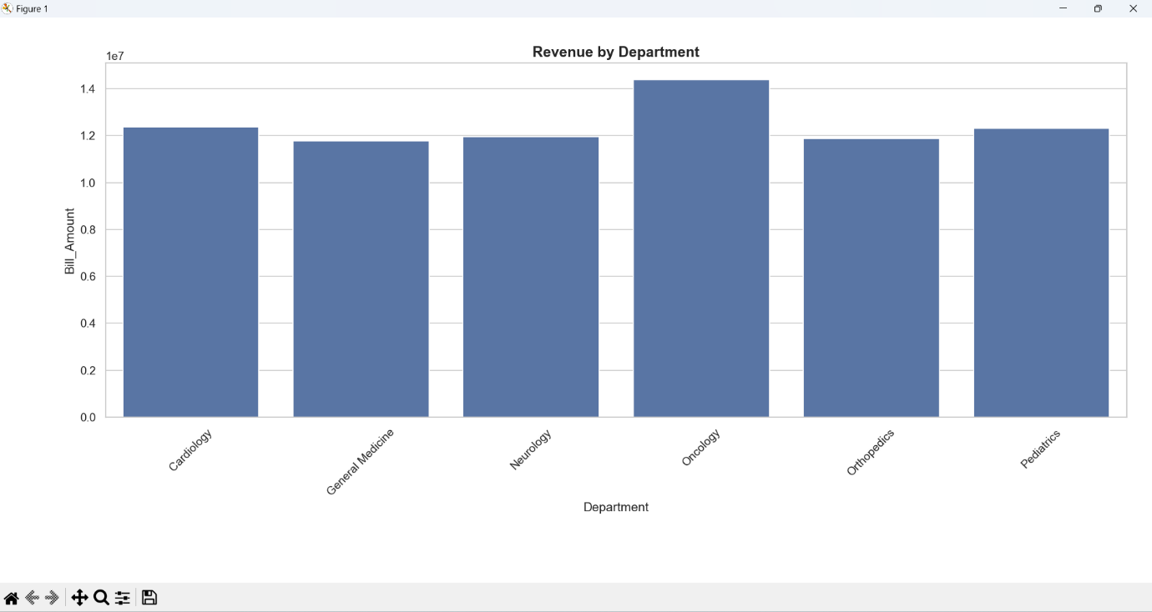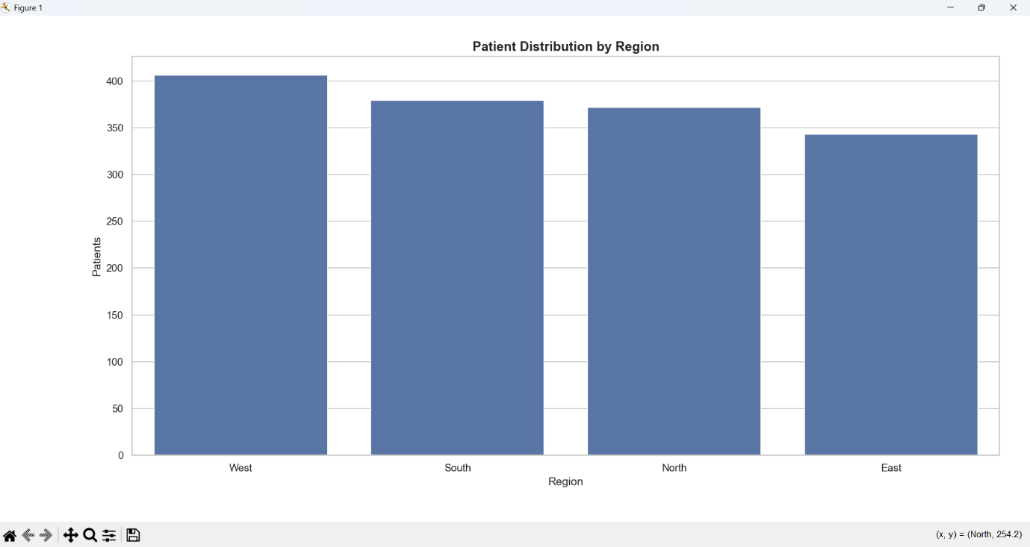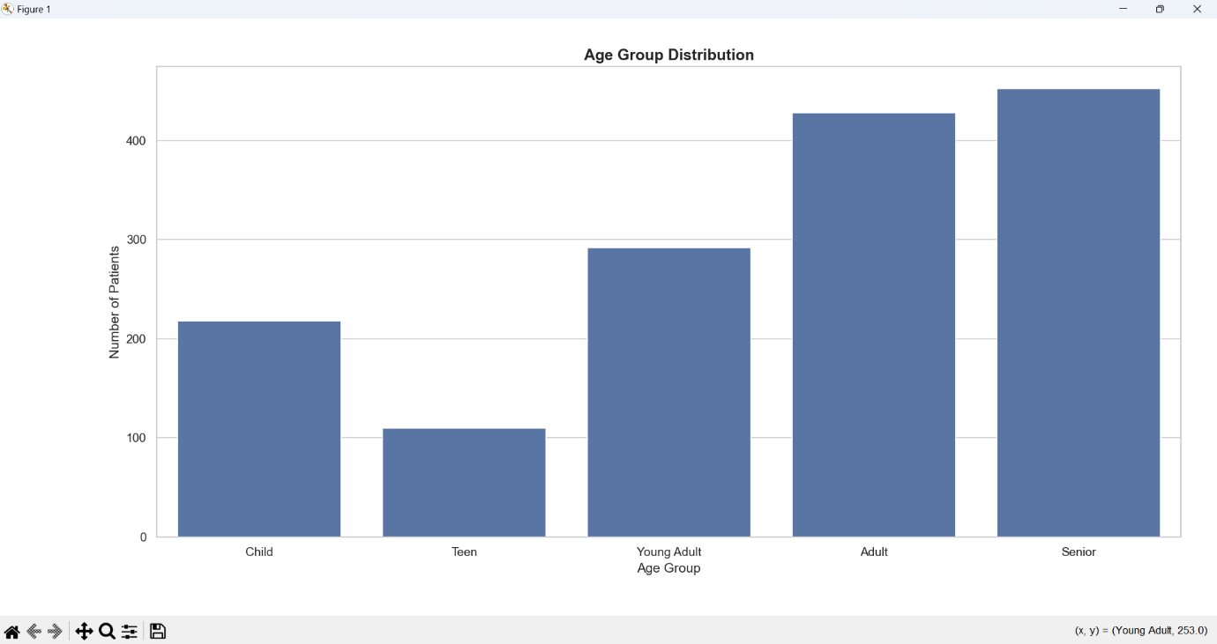

**Theory**

Healthcare data analysis plays a vital role in understanding hospital performance, patient demographics, disease trends, and revenue distribution. By analyzing structured hospital data, we can identify critical insights such as most common diseases, financial contribution by departments, and regional variations in patient flow.

This project uses Python, Pandas, Matplotlib, and Seaborn for end-to-end data analysis. The process involved:

1. Data Cleaning → Removing duplicates & missing records for accuracy.

2. Exploratory Data Analysis (EDA) → Summarizing revenue, patient count, and age groups.

3. Visualization → Presenting insights in an interpretable form using bar graphs.

Such analysis helps hospitals in resource allocation, disease management, financial planning, and policy-making.

**CONCLUSION :-**

From the above analysis, it is evident that the hospital handles a diverse patient base with a major focus on adult and senior citizens, who contribute significantly to both patient count and revenue. The high revenue in Oncology reflects the economic burden of cancer treatments, while Hypertension and Covid-19 underline the importance of preventive care and epidemic preparedness.

Regional variation in patient distribution indicates the need for better healthcare outreach programs in under-represented areas like the East. Moreover, the balanced presence of multiple diagnoses confirms the hospital’s role as a multi-specialty center catering to varied medical needs.

In summary, this analysis provides valuable insights for:

Hospital Administration → Financial planning & departmental investments.

Doctors & Researchers → Disease prevalence tracking.

Policy Makers → Identifying underserved regions and strengthening healthcare delivery.

Thus, healthcare data analysis not only improves operational efficiency but also saves lives by enabling data-driven decision making.